Day 3: Pulling Focus

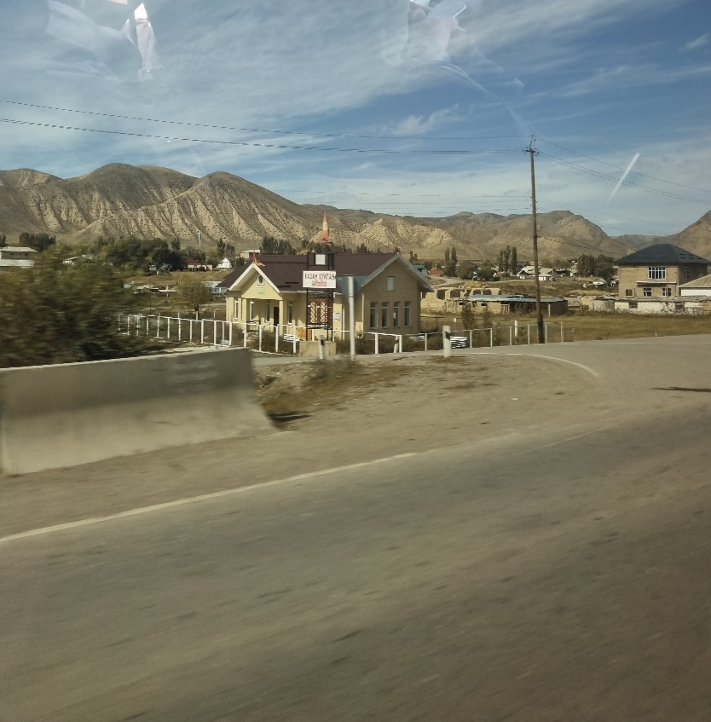

*When Aiganysh was travelling by car, she took this photograph of a building. Despite her best efforts, the building came out a little blurry. Can you figure out what the building is used for?*

*What is the function of this building?*

Zooming in on this photo, I can see reflections in the sky, that I thought could be interesting at first glance. However, they seem to be just reflections of the inside of the car. Then, I looked at the sign above the building. It seems to be a Russian language, but I am not sure. I decided to run the photo through Google Lens, which is able to recognize text and translate it. This resulted in the text: КАЗАН КУЙГАН АЙЫМЫ, which in English means Kazan Kuigan’s Lady. This does not mean much to me, so I decided to Google for the original text. Apparently, Kazan-Kuygan is a village in Kyrgyzstan. Looking to the search results in the original language, I often see mention of an alternative writing of the third word: АЙЫлЫ. This could also be possible, since the blurry picture makes it difficult to exactly identify the characters. When Googling this adjusted text I see a TikTok result, that looks very much like the house in the picture. The TikTok video gives me no further information on the function of the building however. Since I know the building is in this small village, I decided to look for it in Google Maps, to hopefully find more information. The house is located at an intersection with hills in the background. I can also use the electricity poles as orientation. I eventually find the sign at an intersection, but there is no house (see below). The pictures from Google Maps are from 2015, so the building should be relatively new. I tried to zoom all the way in to see if the building would be tagged as something, and indeed it is tagged as Biblioteka, which presumably means:

**library**.

